**Plugging into the Future: An exploration of**

**Electricity consumption** patterns

PROJECT **REPORT**

1. **INTRODUCTION**
   1. **Overview**

Electricity consumption is an essential component of the modern life. It not

only provides clean and safe light throughout the day, but also in many countries refreshes homes on hot summer days, and in others warms them in winter. In all countries, it allows the use of electrical and electronic equipment in which the use of electricity is essential to ensure their proper functioning. Although hundreds of millions of Americans and Canadians connect to the power grid every day, most of them do not think about how they get the electricity consumed, and how much it costs to produce it. Keeping the North America region energized is actually an amazing feat, a daily miracle.

* 1. **Purpose**

Energy efficiency is the ability to obtain the best results using the least amount of energy resources possible. Through energy efficiency, users can consume power more responsibly.

With the aim of helping buyers choose products that consume less energy while saving money, the European Union's Directive 92/75EC states that household appliances must have an energy rating label.

As a consumer, if you've ever had to purchase one of these products, you must've noticed that they all include a label showing a color scale. This is a ranking system that ranges from green to red that evaluates different parameters such as the appliance's energy consumption, the noise it can make, its annual CO2 emissions or, for example, in the case of washing machines, the amount of water it uses per wash cycle.

**2. Problem Definition & Design Thinking**

**2.1. Empathy Map**

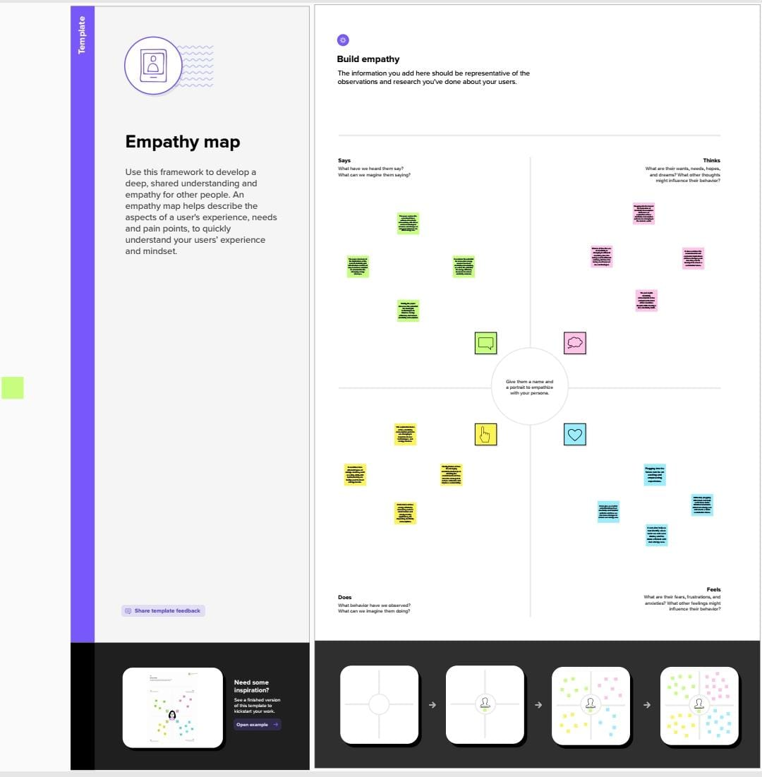

**2.2. Ideation & Brainstroming Map**

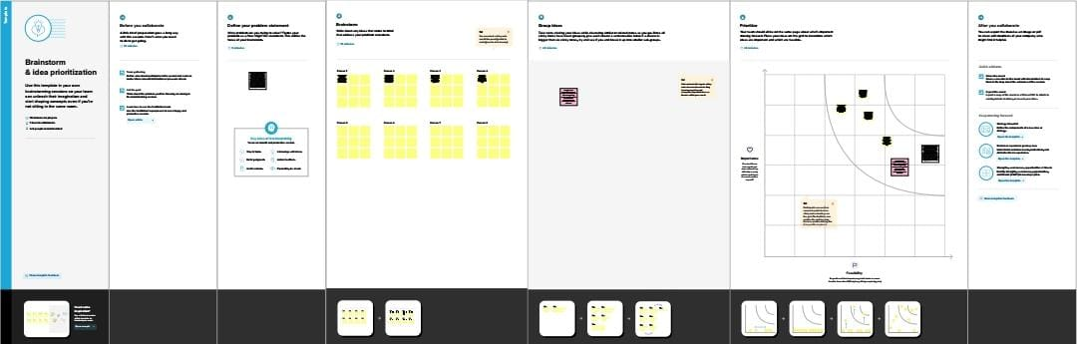

1. **RESULT**

Sheet:

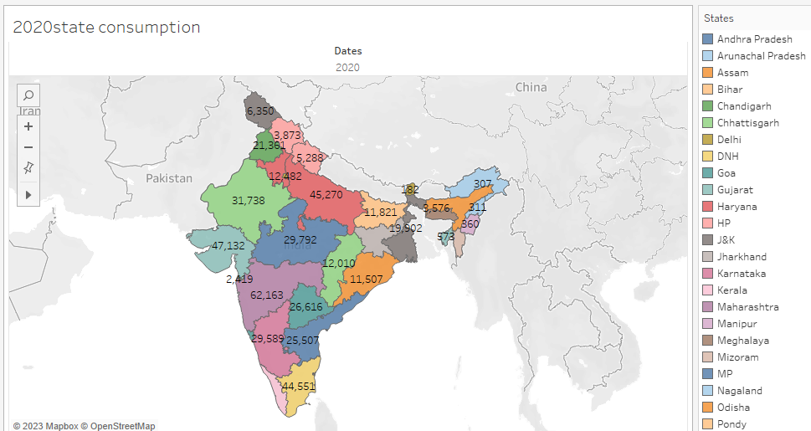

Dashboard:

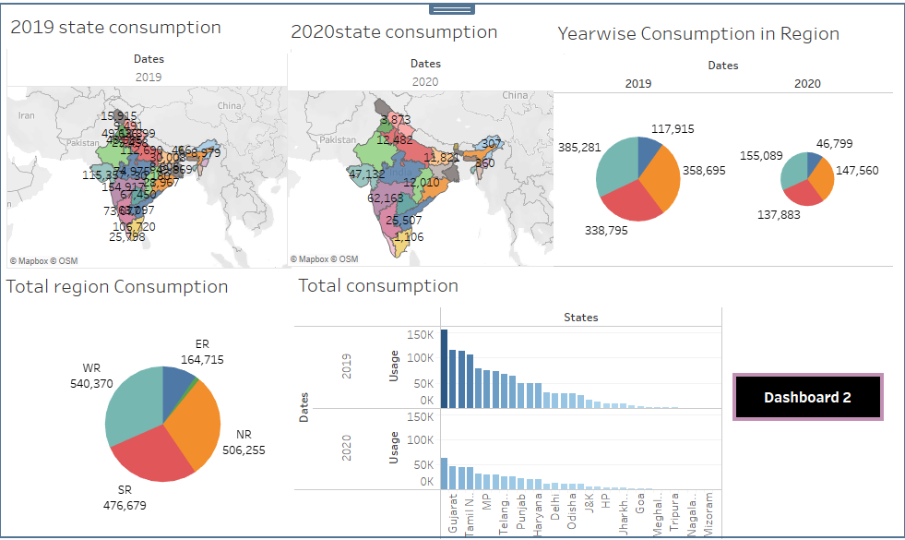

Story:

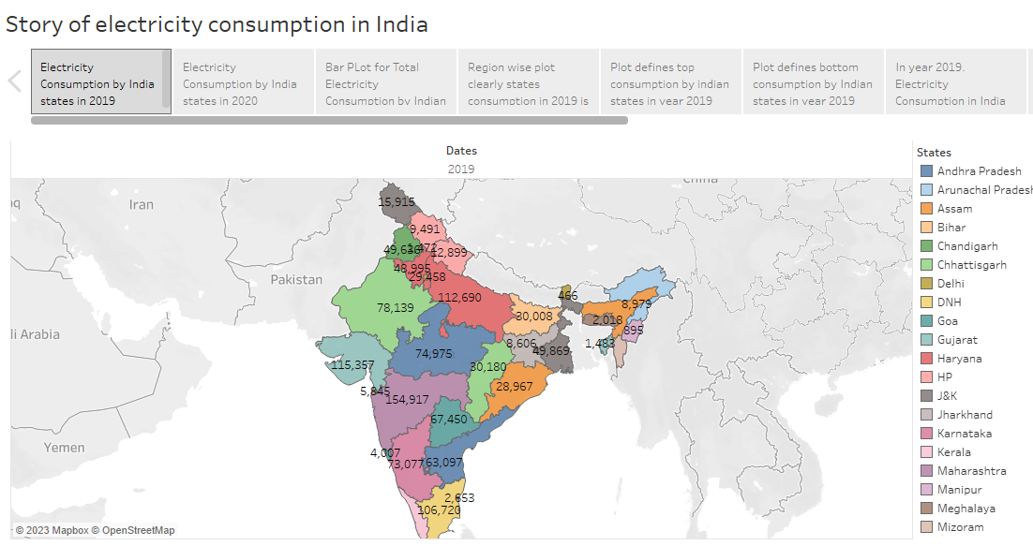

**4. I. ADVANTAGES**

**.** It is a clean, safe, cheap and convenient source of energy

. Lower maintenance cost

. More efficient

. No tailpipe emission

. We all know that it  can be set up in many sizes

**II.**  **DISADVANTAGES**

. More expensive than gasoline

. Loss of fish species

. Sometimes messes up wildlife

. Dependent on precipitation

. Damming can cause loss of land suitable for agriculture as well as recreation

**5. APPLICATIONS**

India is the world's third-largest producer and third-largest consumer of electricity. The national electric grid in India has an installed capacity of 370.106 GW as of 31 March 2020. Renewable power plants, which also include large hydroelectric plants, constitute 35.86% of India's total installed capacity. During the fiscal year (FY) 2019–20, the total electricity generation in the country was 1,598 TWh, of which 1,383.5 TWh generated by utilities. The gross electricity consumption per capita in FY2019 was 1,208 kWh.

In 2015-16, electric energy consumption in agriculture was recorded as being the highest (17.89%) worldwide. The per capita electricity consumption is low compared to most other countries despite India having a low electricity tariff.

**6. CONCLUSION**

The aim of this project was to identify the variables that influence the generation, the consumption and the price of the electricity in United States.

We have seen that the generation of electricity in American states is driven by the number of commercial and industrial customers. Concerning the electricity consumption, it is influenced by the energy production itself and the amount of commercial customers. Our prediction models are quite accurate and confirmed the results of our exploratory data analysis. About our models, we should not forget that lots of variables can explain the electricity consumption and production as we have seen during the eploratory data analysis, but we only used the most significant ones.

For the structure of the electricity production, we have seen that the energy mix varies tremendously from one region to another and from one state to another. We cannot determine whether a mix defines the price per KWh or not. However, power generation using coal and hydropower is correlated with low energy costs. In addition, KWh prices will be higher for states belonging to the following regions:

**.** Middle Atlantic

. New England

. West Pacific

Even if we considered to study the fluctuation of the electricity price for the next years, it turned out impossible to achieve a result. Therefore, it would be interesting to analyse accurate external data such as the weather, the cost price per KWh per energy, the political decisions, etc. Those aspects have a direct influence on the price of energy.

Finally, regarding the Californian state, we were able to model the average power per hour over a year. We see that renewable energies are subject to seasonality. The power of renewable energies is highly volatile, which makes them difficult to predict. For this reason, it is more difficult to predict these data in a very short term.

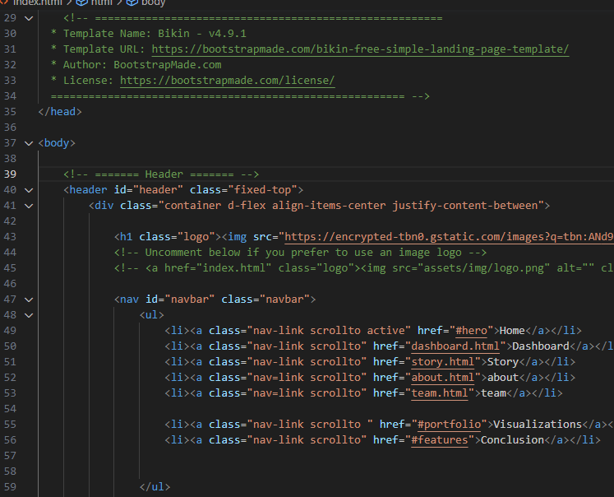

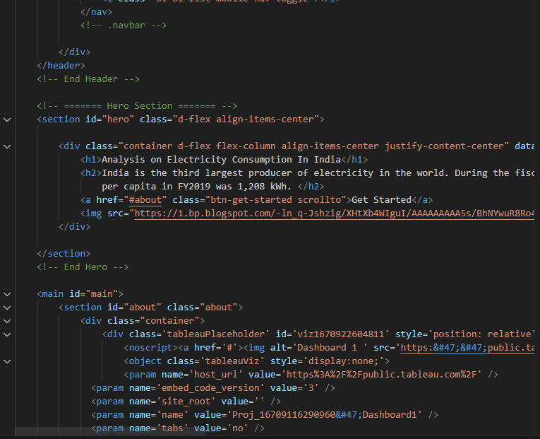

**SOURCE FOLDER LINK:**

[**https://drive.google.com/drive/folders/1j28Rptm1rF-bkJ3uhIItLTzGStfqRoiF?usp=share_link**](https://drive.google.com/drive/folders/1j28Rptm1rF-bkJ3uhIItLTzGStfqRoiF?usp=share_link)

**SOURCE CODE LINK:**

[**https://drive.google.com/file/d/1qhPKHdcQL_vfjJ3wy3G6Hug8Cc8OhL-A/view?usp=share_link**](https://drive.google.com/file/d/1qhPKHdcQL_vfjJ3wy3G6Hug8Cc8OhL-A/view?usp=share_link)

**TABLEAU PUBLIC LINK**

**1.Dashboard**

[**https://public.tableau.com/views/dashboard1_16831069572510/Dashboard1?:language=en-US&:display_count=n&:origin=viz_share_link**](https://public.tableau.com/views/dashboard1_16831069572510/Dashboard1?:language=en-US&:display_count=n&:origin=viz_share_link)

**2.Story**

[**https://public.tableau.com/views/Story1_16831083125770/StoryonElectricityConsumptioninIndia?:language=en-US&:display_count=n&:origin=viz_share_link**](https://public.tableau.com/views/Story1_16831083125770/StoryonElectricityConsumptioninIndia?:language=en-US&:display_count=n&:origin=viz_share_link)

**VIDEO DEMONSTRATION:**

[**https://drive.google.com/file/d/1hCpOm7KdJhxcGbgF7AiTsreuzPRKp1R5/view?usp=share_link**](https://drive.google.com/file/d/1hCpOm7KdJhxcGbgF7AiTsreuzPRKp1R5/view?usp=share_link)